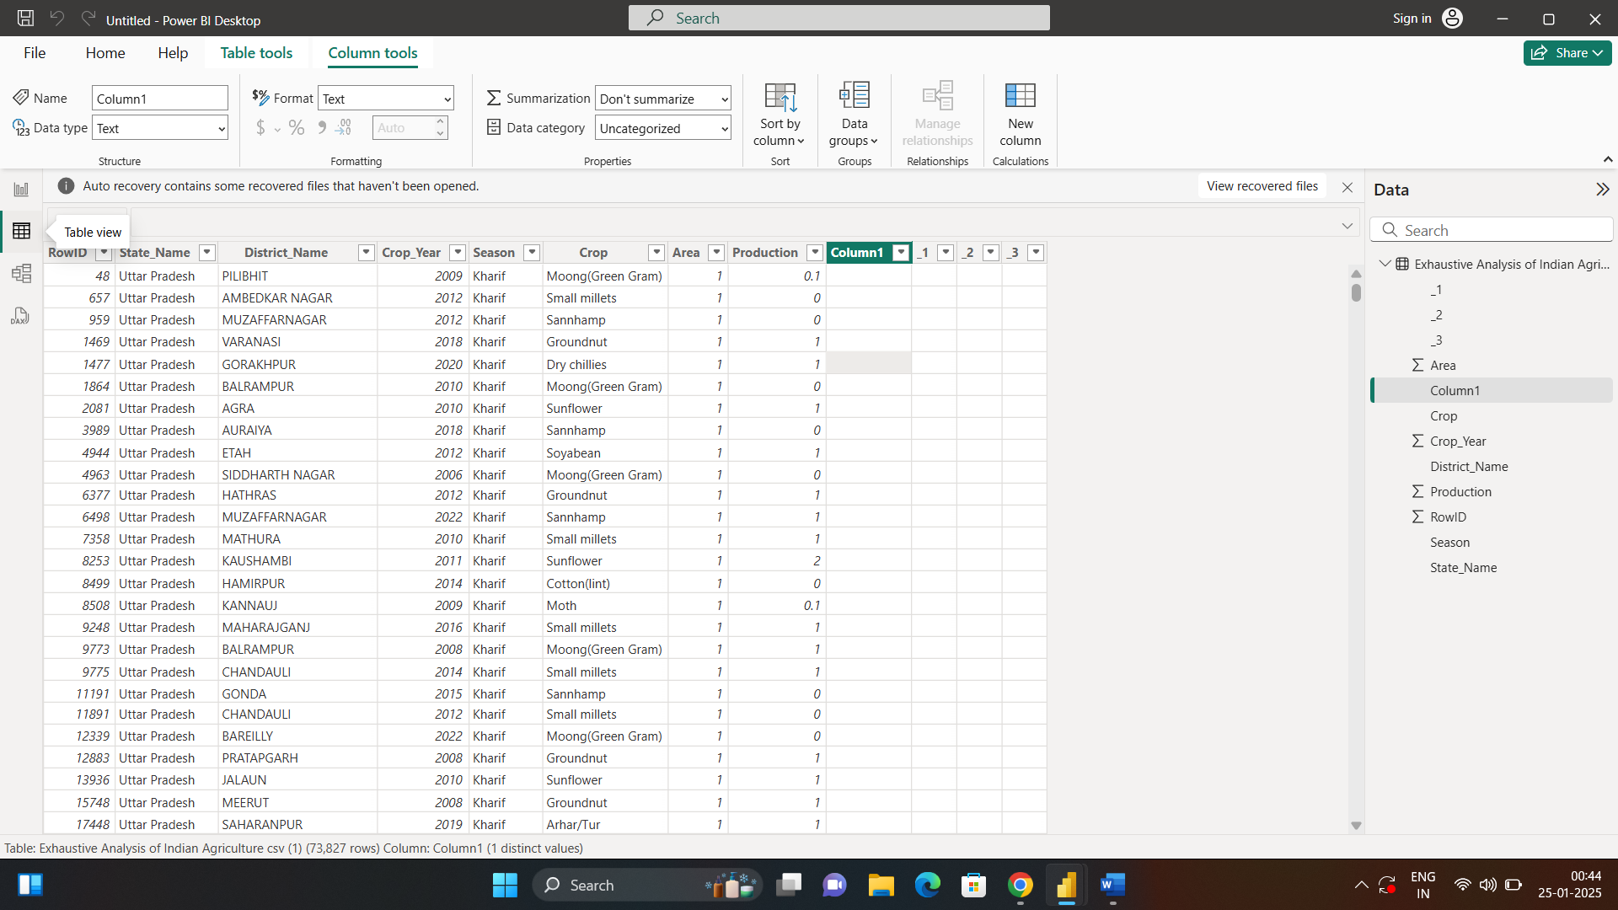

First open Power Bi

With the help of get data load a text csv file in it

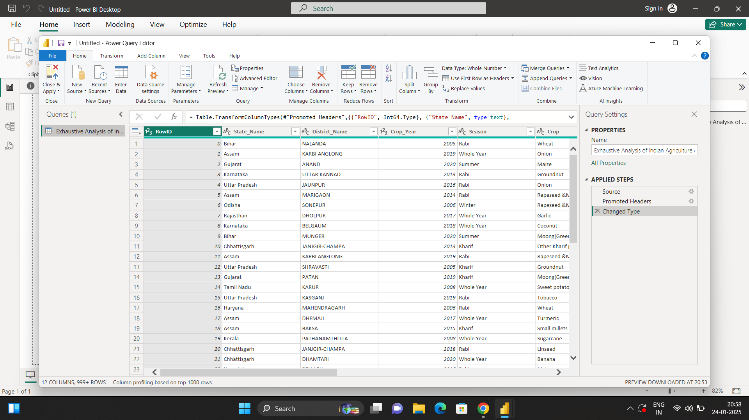

Then transform the data

And new tab will open that is – Power query editor

We can perform operations such as delete rows…and much more.

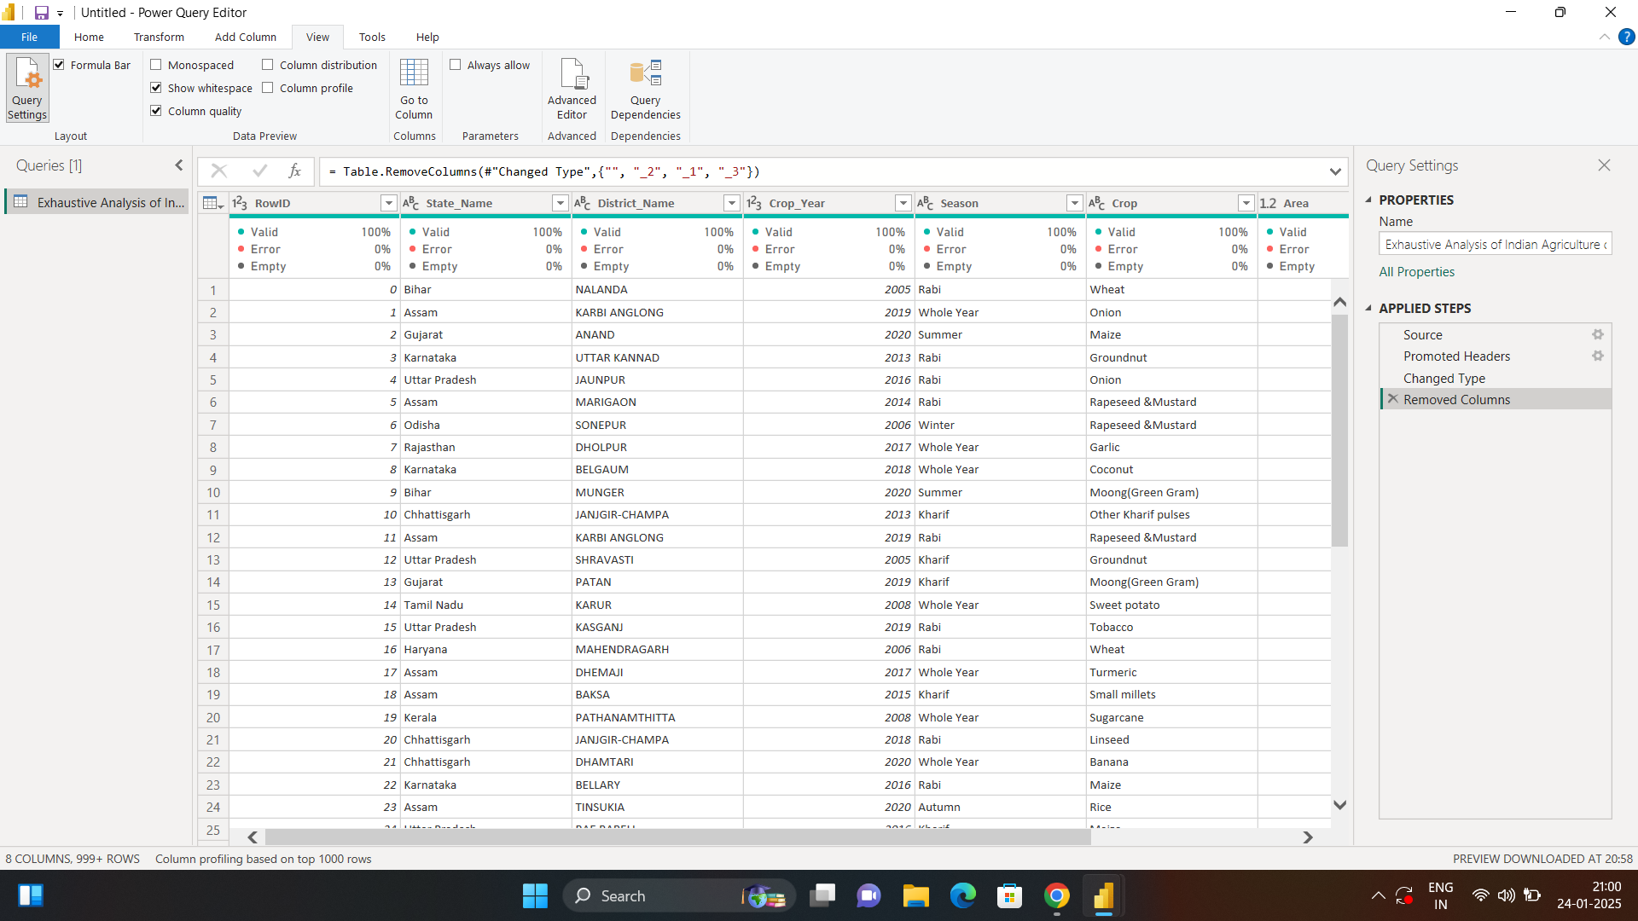

For checking if the errors are present in the data or not, we have to go in files and check the column quality.

Also we can find the empty spaces

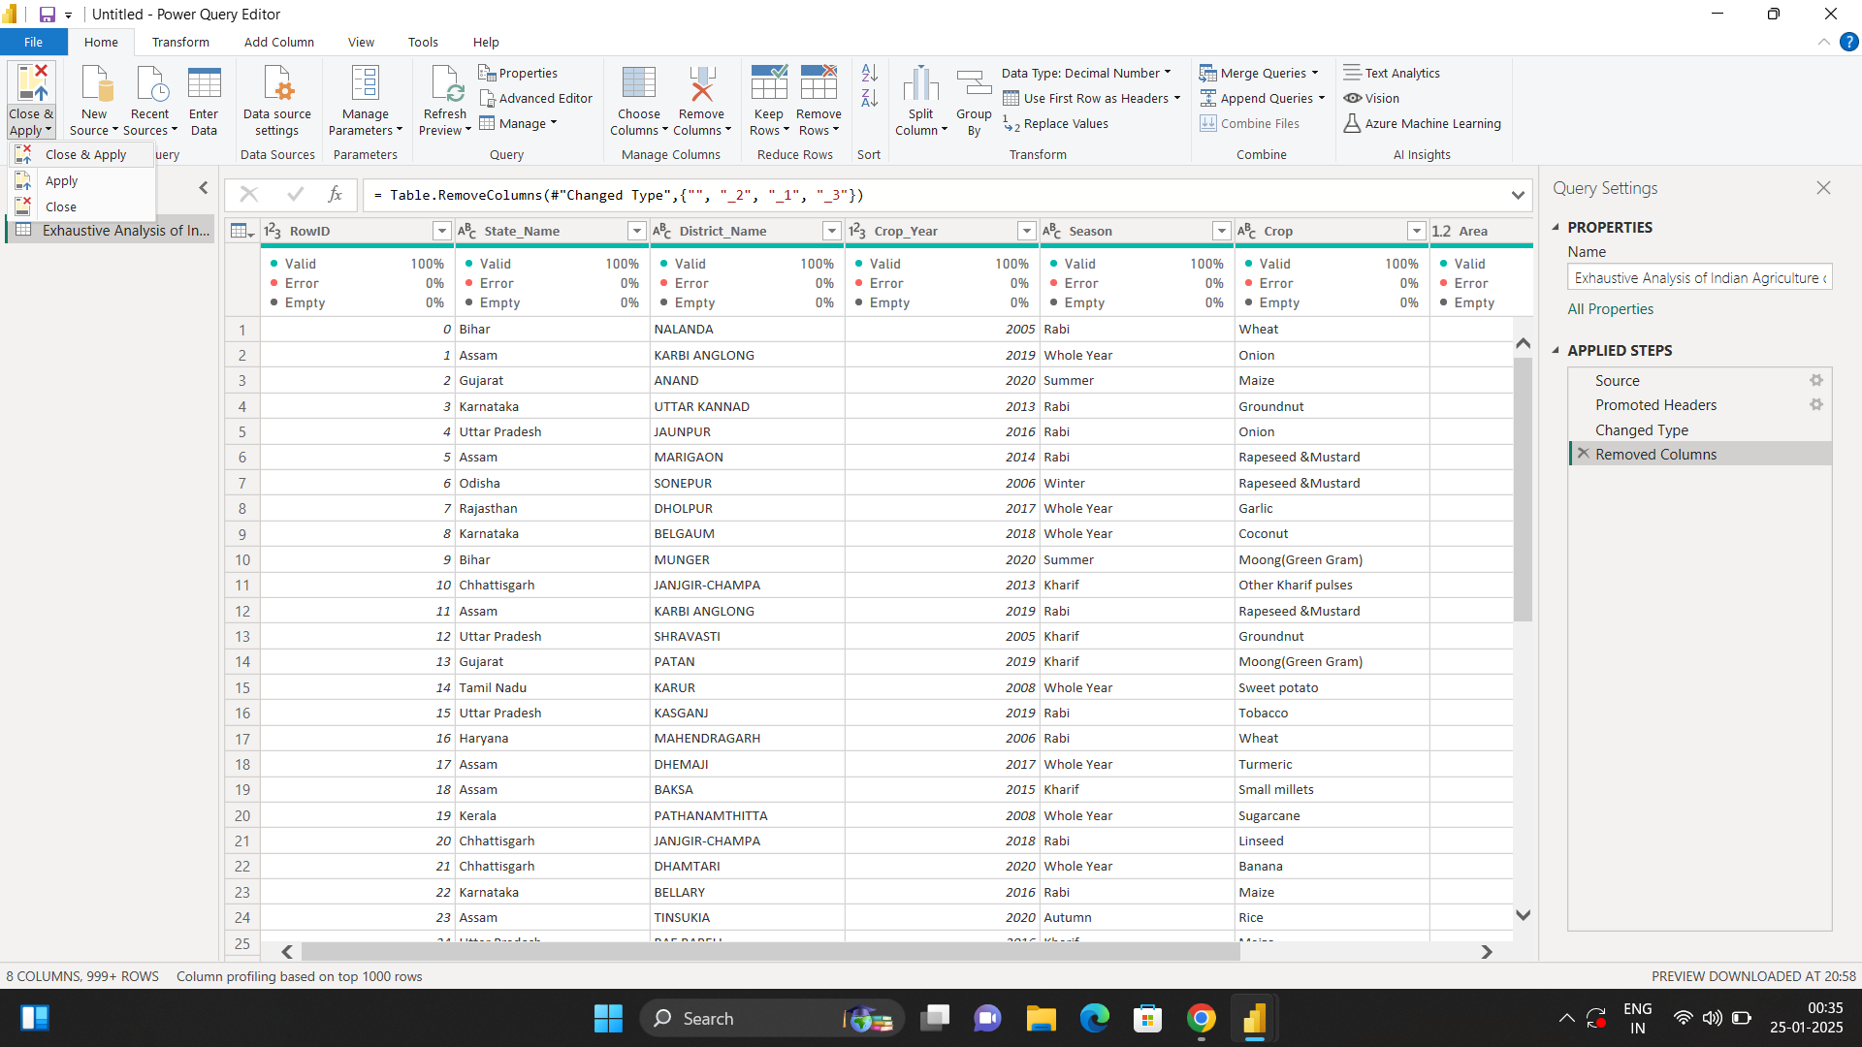

After removing unnecessary rows by right clicking it and removing it , we have to make chances in power bi desktop,

For that click on file, then close and apply

Thus ,Changes will be reflected on power bi desktop.

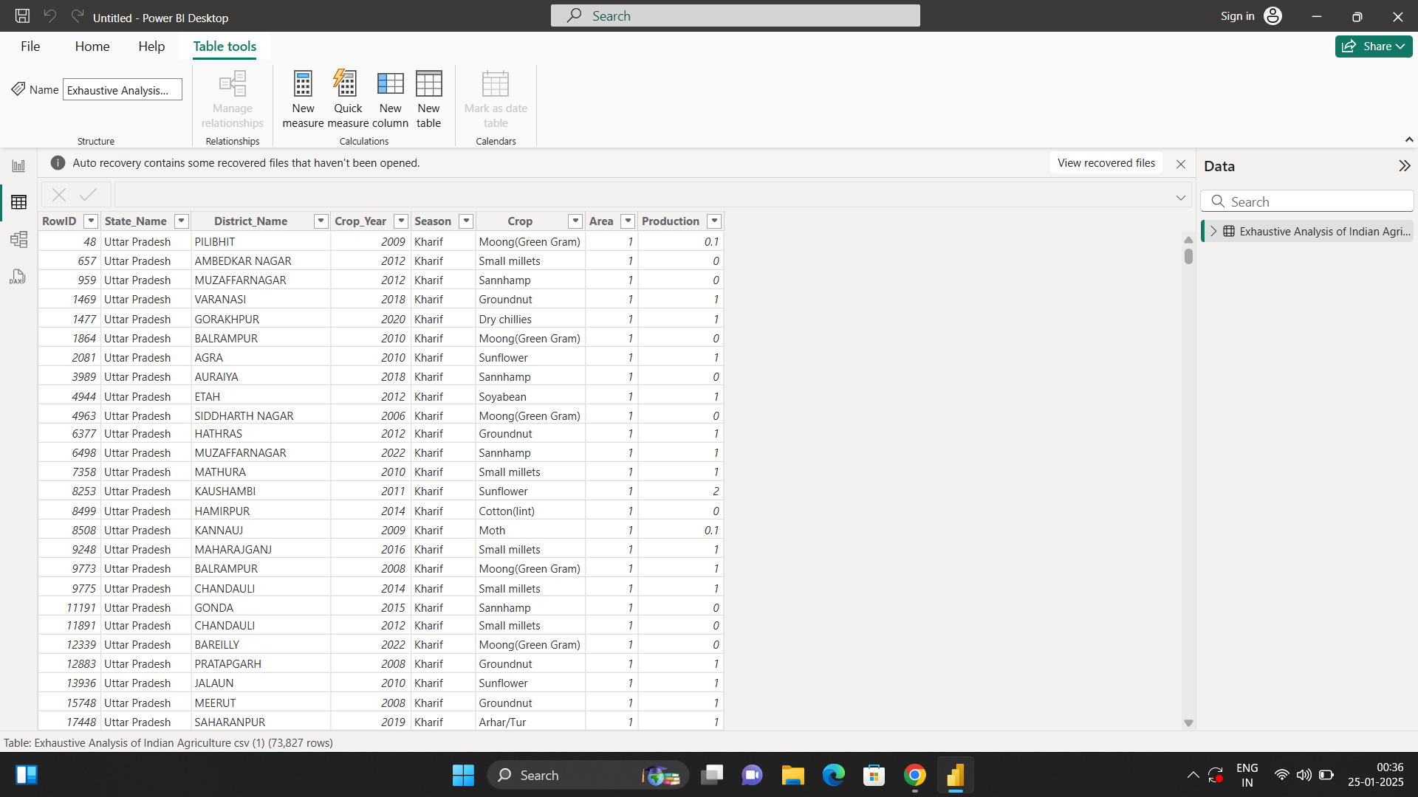

Hence we can see the rows are removed.